Pre-Calculus/Trig3 Name
Applications: Law of Sines and Cosines Block Date

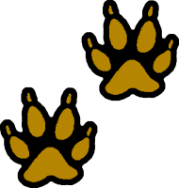
- The figure at the right shows footprints of a carnivorous dinosaur taken from the Glen Rose formation in Texas. The pace is the distance from the left footprint to the right footprint, and vice versa. The stride is the distance from the left footprint to the next left footprint. If an animal walks in such a way that the footprints are directly in line, the stride will be twice the pace. But usually, the footprints show a “zigzag” pattern that can be described numerically by the step angle, θ. An efficient walker has a step angle that approaches 180⁰, meaning that the animal minimizes the zigzag motion while maximizing forwards motion.
pace
pace
stride
θ
step angle


At the Glen Rose formation in Texas, an anthropologist measured the pace and stride of footprints made by a bipedal (two-footed), carnivorous (meat-eating) dinosaur and the hind feet of an herbivorous (plant-eating) dinosaur. The data are shown in the figure.
315.0
158.7
162.6
273.1
186.7
167.6
A
B
C
D
E
F
  - Find the step angle for each dinosaur.
  - What can you tell about the motion of each dinosaur from its step angle?

- Surveying Two sides of a triangular plot of land have lengths of 400 feet and 600 feet. The measure of the angle between those sides is 46.3º. Find the perimeter and area of the plot.

- While surveying Overlook Cave, Mike measures the angle of elevation from his line of sight to the top of a rock formation as 22º. The rock formation is 10 feet away and he is measuring from a point 3 feet above the floor of the cave and is 5ft 6inches tall. To the nearest hundredth of a foot, how high is the rock formation?

- If Crystal is standing on a 15 foot high diving board and is 5 feet 3inches. Her friend Charlie is 48 feet from the spot in the pool underneath the diving board, what is the angle of depression from Crystal to Charlie, to the nearest hundredth of a degree?

- Aviation A pilot takes off from the Newport News Airport in Newport News, Virginia. The pilot flies out towards the Atlantic Ocean and after reaching point C, the plane develops mechanical difficulties, and the pilot needs to return to either the Newport News or Norfolk Airport. How far is it to the nearer airport?
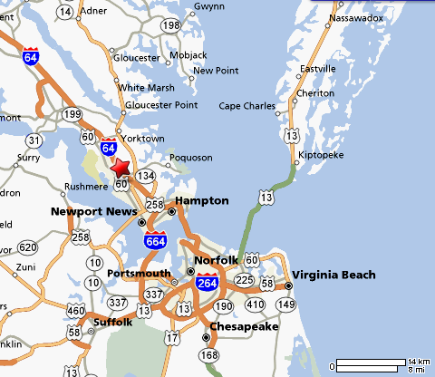

C

58º

96º

24.2miles

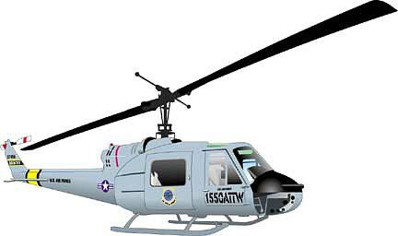
- Emergency Medicine A medical rescue helicopter has flown 45 miles from its home base to pick up an accident victim and 35 miles from there to the hospital. The angle between the two legs of the trip was 125º. The pilot needs to know how far he is now from his home base so he can decide whether to refuel before returning. How far is the hospital from the helicopter’s base?
Hospital
Accident
Base
125º
45mi
35mi

- Jenn is standing on a 40 foot cliff overlooking a river and she is 5ft 9inches tall. The angle of depression to the near side of the river is 64º, and the angle of depression to the far side is 35º. How wide is the river, to the nearest hundredth of a foot?

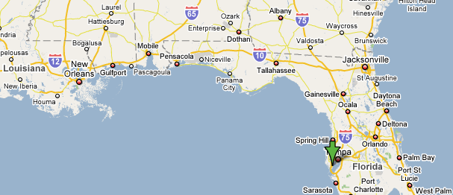
- Geography Use the information in the map to find the shortest distance from St. Petersburg, Florida (marked by the arrow) to New Orleans, Louisiana. The angle at Tallahassee, Florida, measures 125º and the angle at Pensacola, Florida measures 166 º. (Hint: First find the distance from St. Petersburg to Pensacola.)
200mi
238mi
211mi

